1. INTRODUCTION :

Unearthing the environmental impact : A Global CO2 emission analysis.

* 1. Overview
* Global warming is one of the biggest challengers currently being faced by the human race. Analysing Global CO2 Emission across countries from 1975 to 2020.Here we are going to analyse and visualize Country wise, Region wise and over all countries.

1.2 Purpose

* To determine the exclusive global emission amount of carbondioxide and other greenhouses gases accumulated over the world. Analysing CO2 Emissions helps to identify excessive energy usage or other inefficiencies.Helps to control emissions thus creating a polluted free environment.

LESS CO2 = LESS COSTS

2. Problem Definition & Design Thinking

2.1 Empathy Map

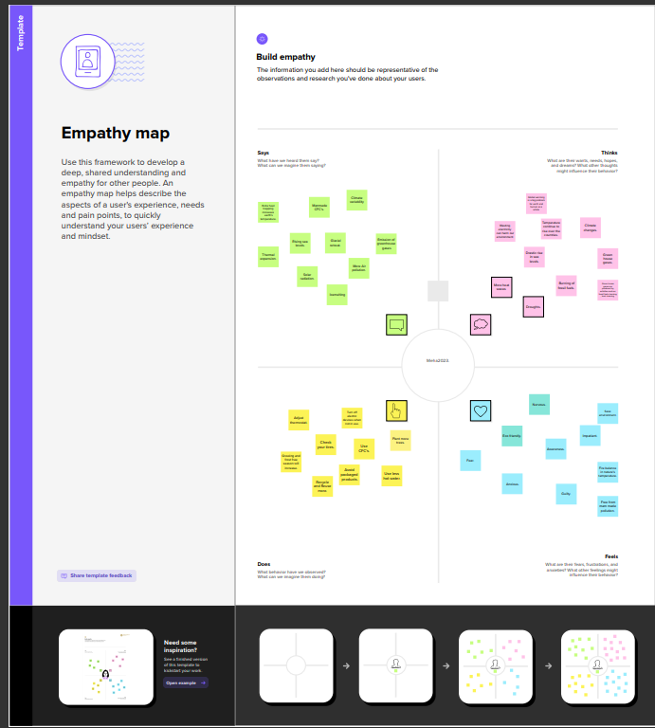

2.2 Ideation and Brainstorming Map

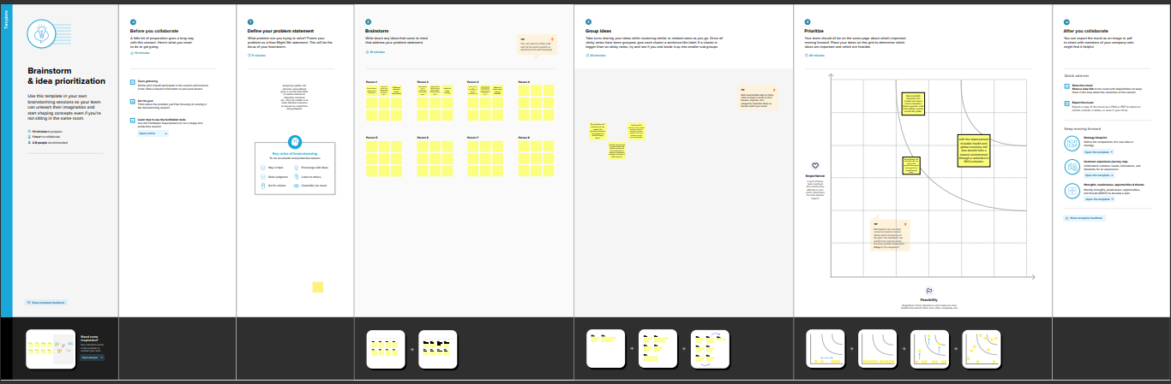

3 Results:

* North America has the highest value of Coal CO2 emission among the continents.

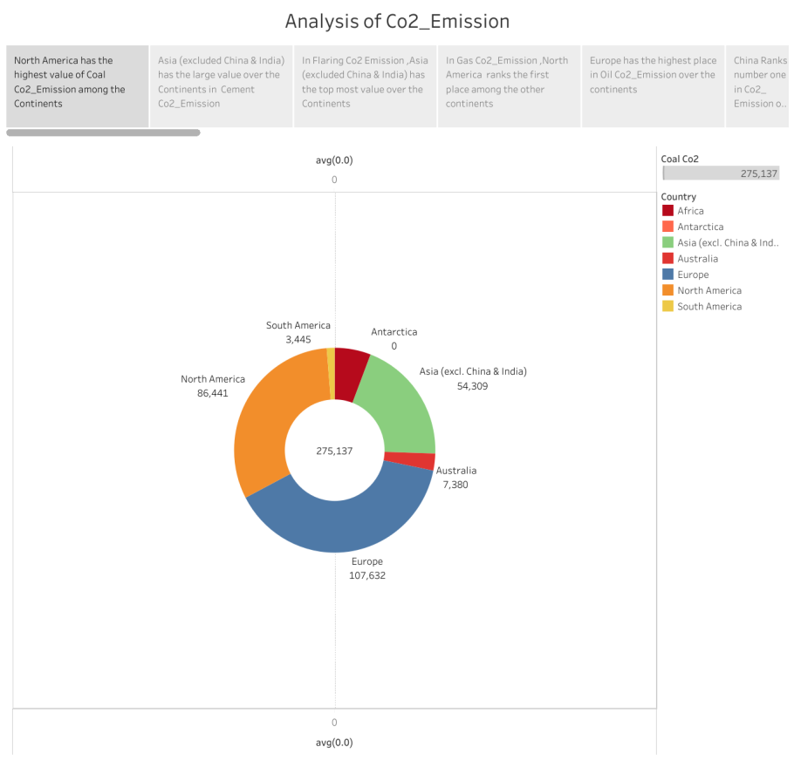

* Asia (excluded china & India) has the large value over the continents in cement CO2 emission.

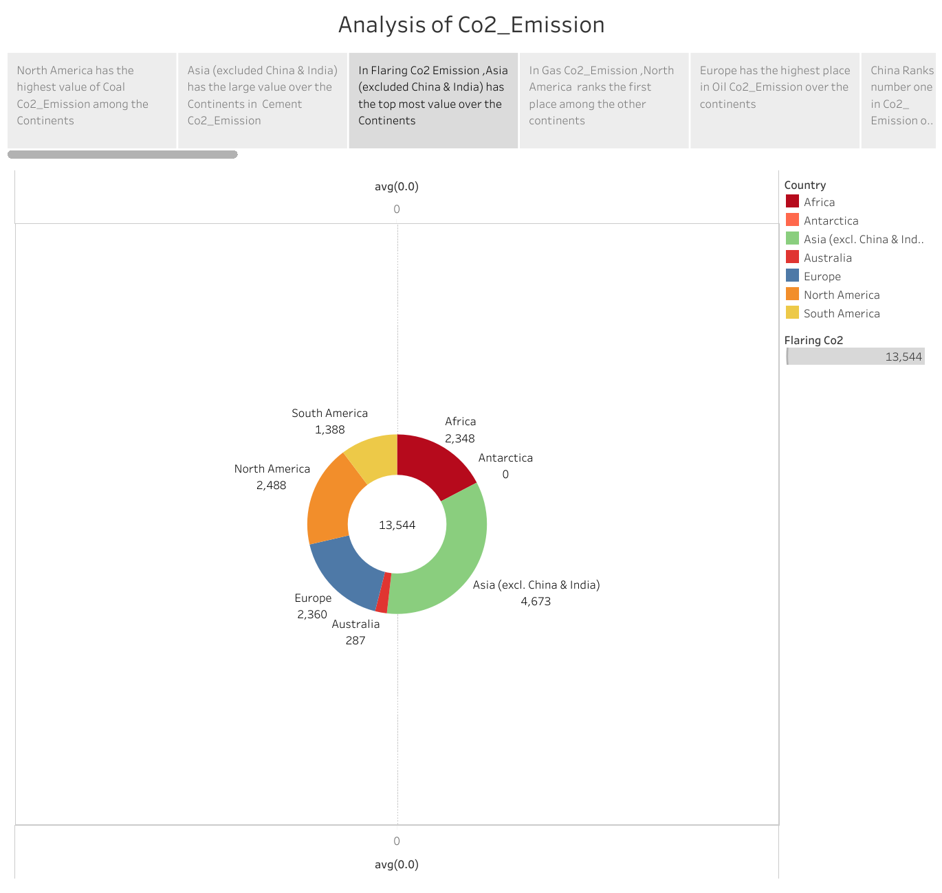

* In Flaring CO2- emission Asia (excl. China & India) has the top most value over the continents.



* In Gas CO2 emission, North America ranks the first place among the other continents.

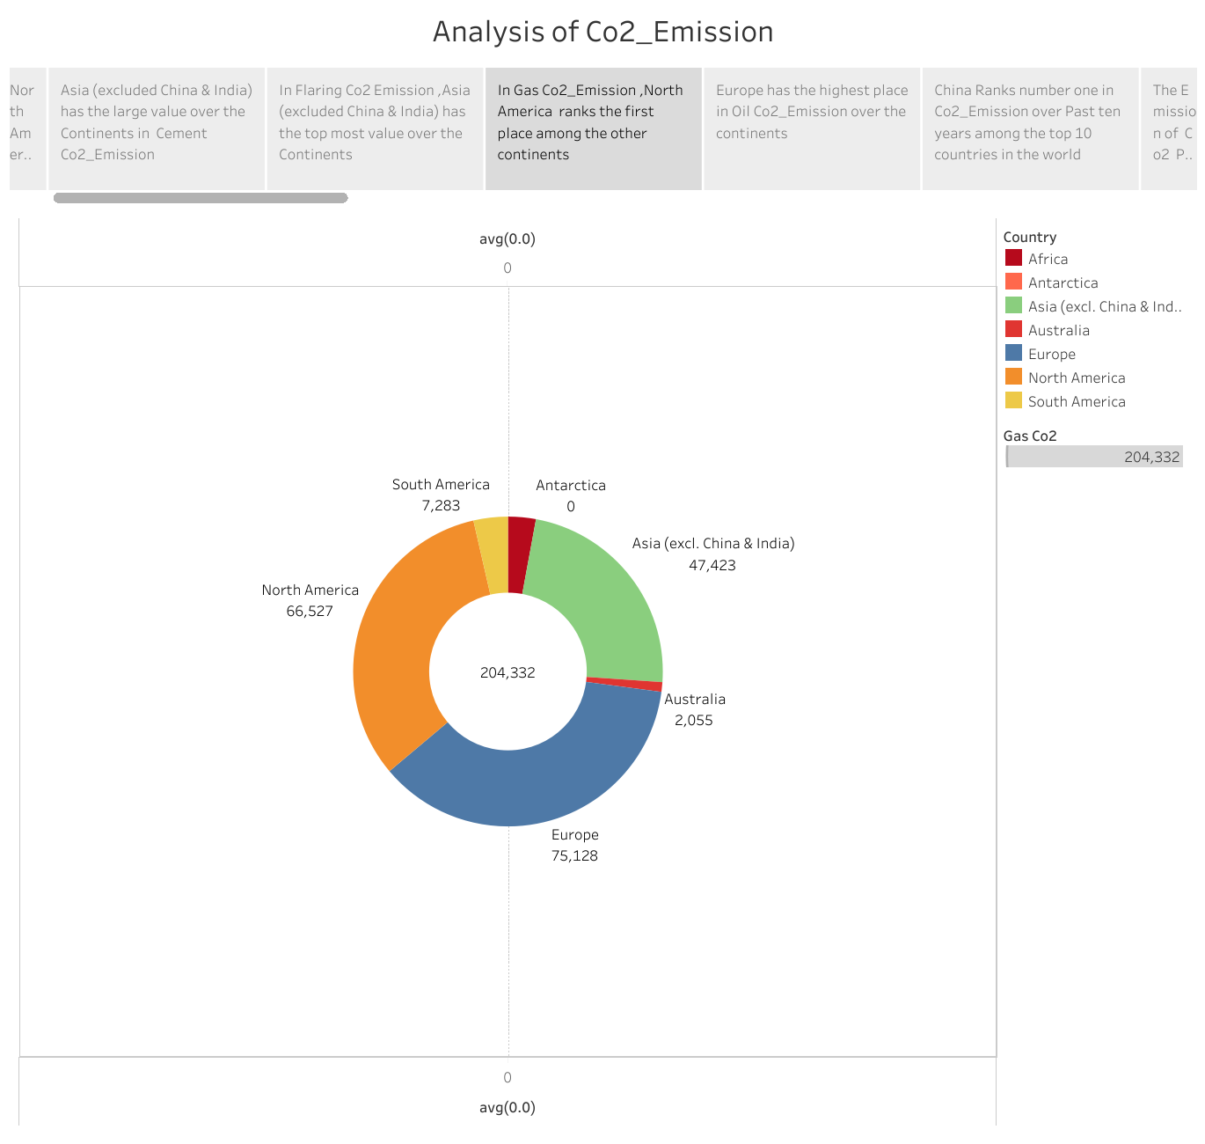

* Europe has the highest place in oil CO2 emission over the continents.

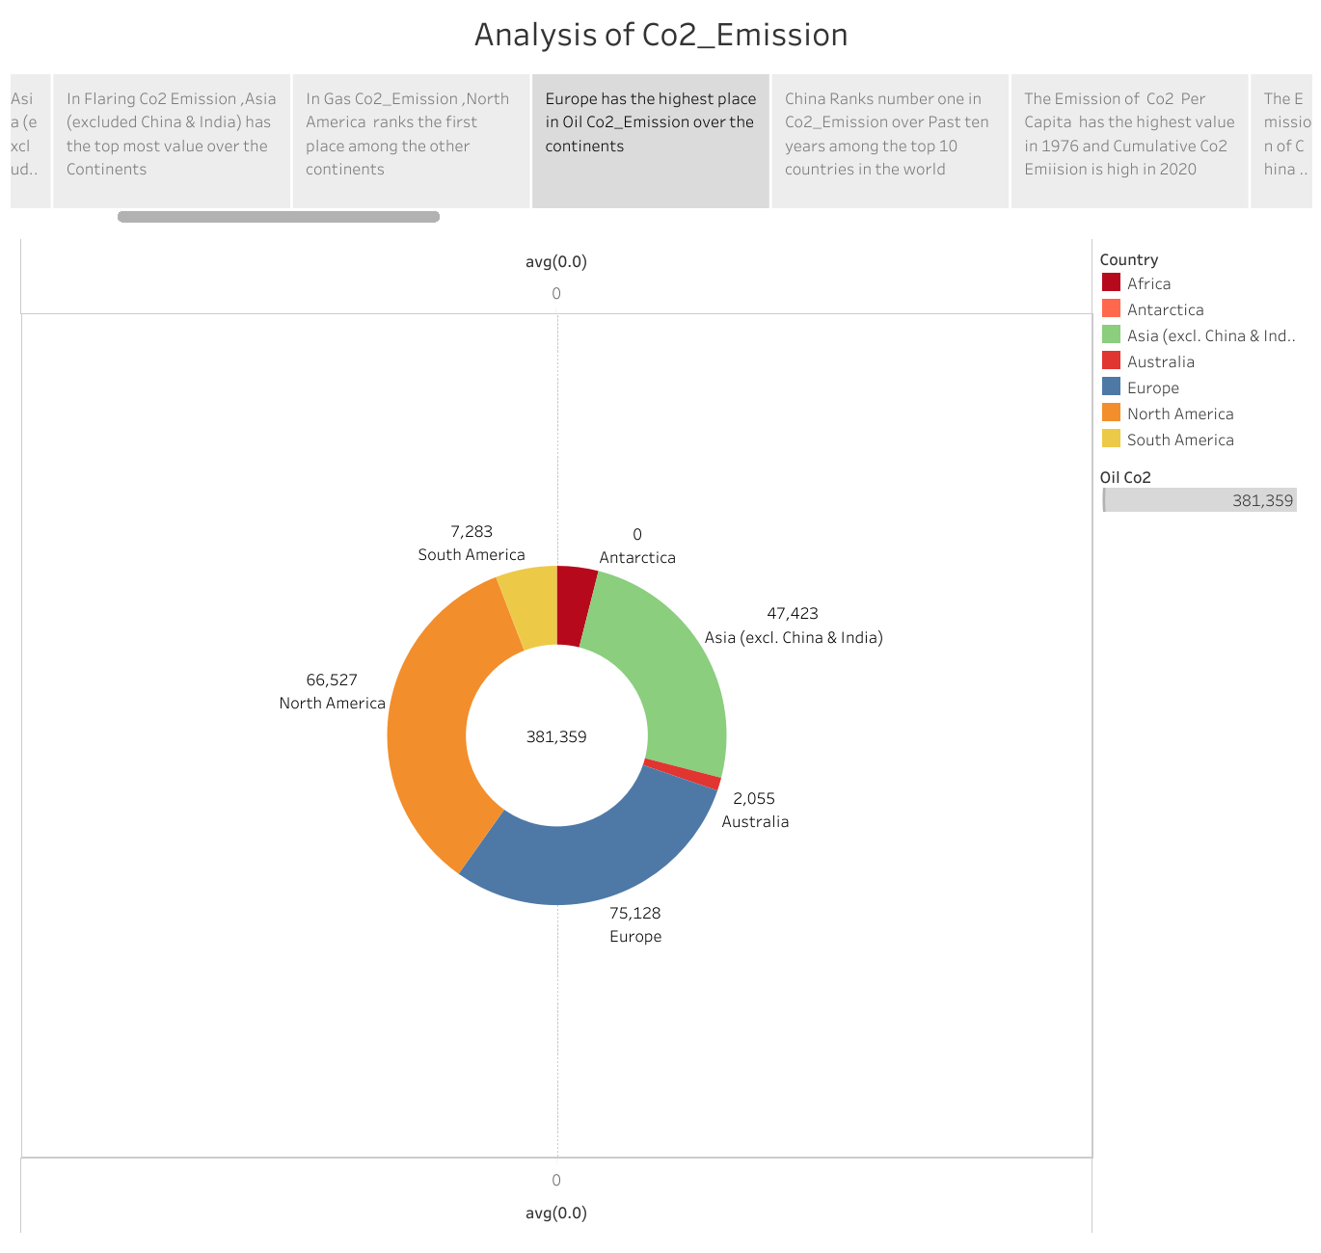

* China Ranks number one in CO2 emission over past 10 years among the top ten countries in the world.

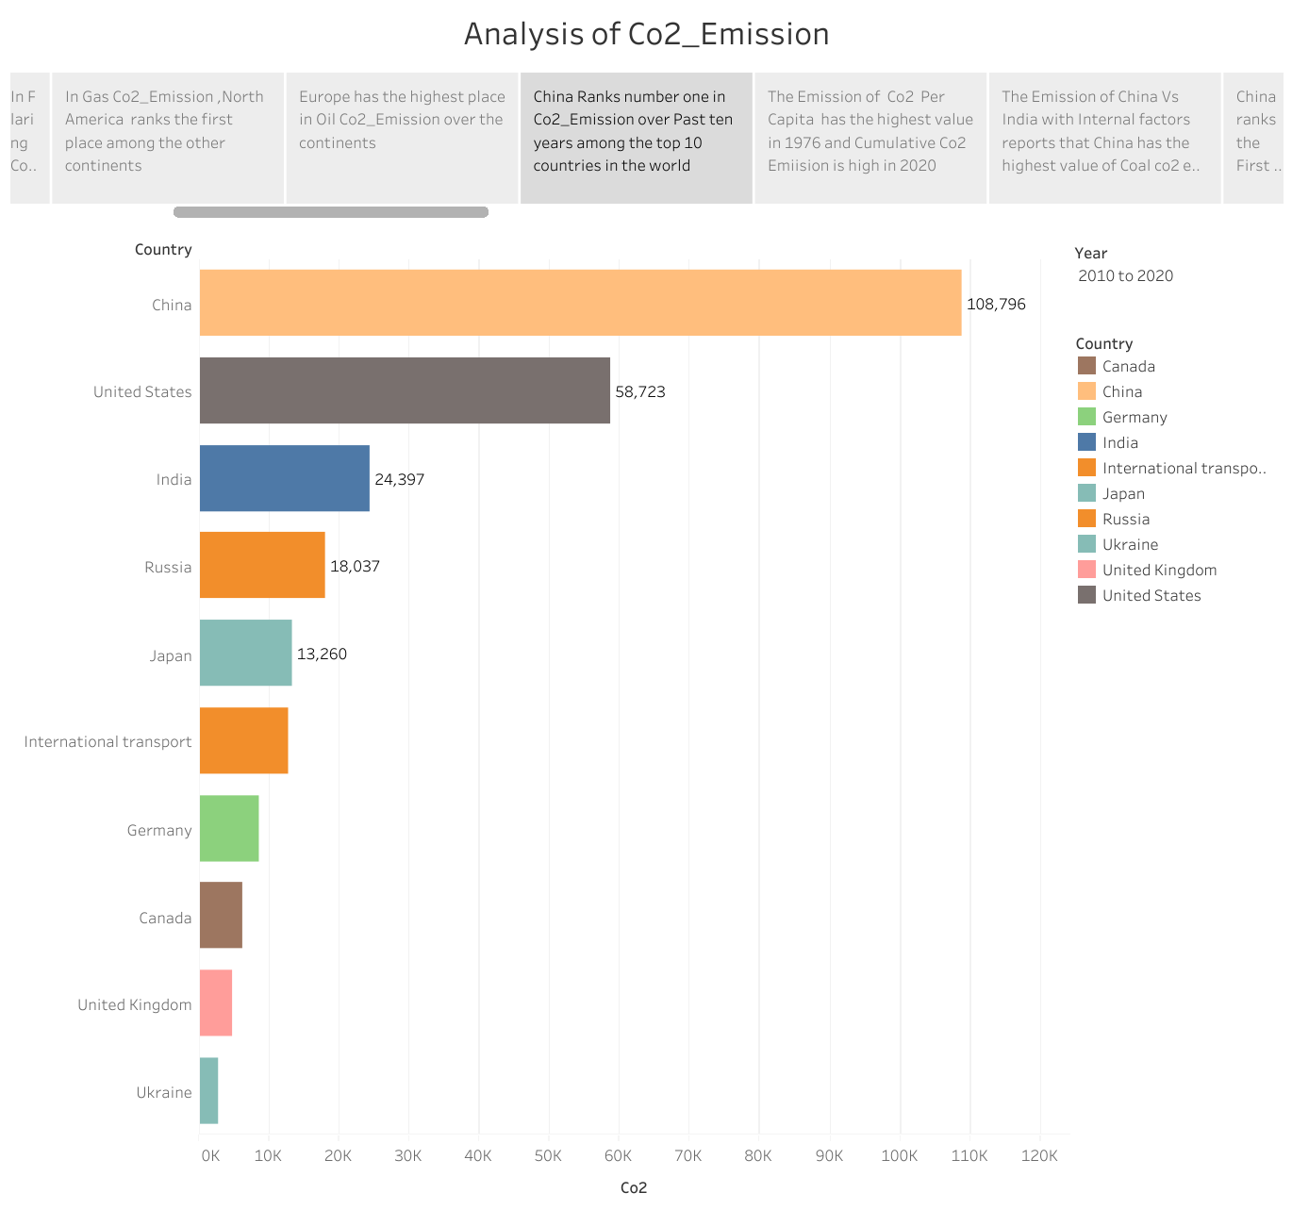

* The emission of CO2 per capita has the highest value in 1976 and cumulative CO2 Emission is high in 2020.

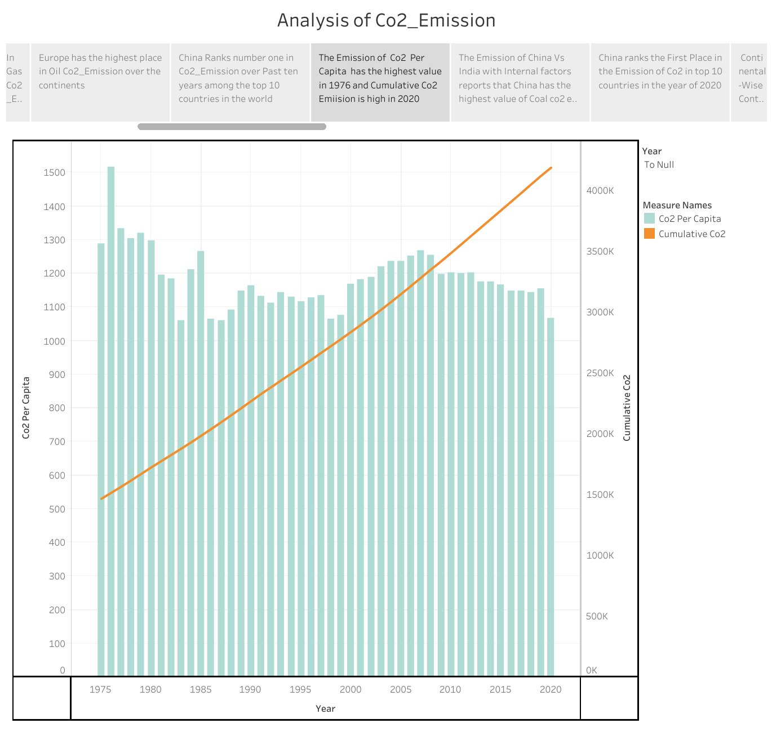

* The emission of china VS India with Internal factors reports that china has the highest value of coal CO2 emission.

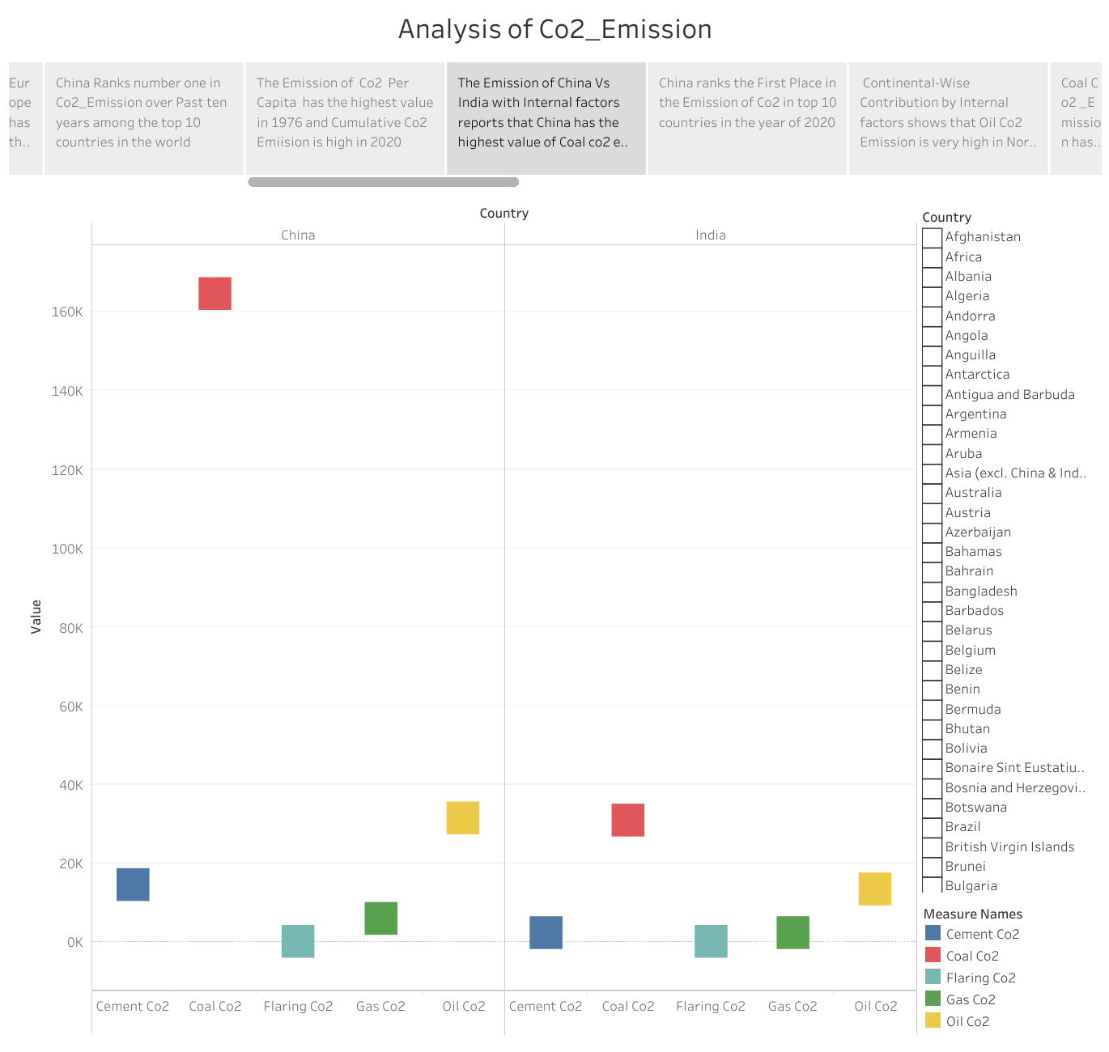

* China ranks the first place in the emission of CO2 in top 10 countries in the year of 2020.

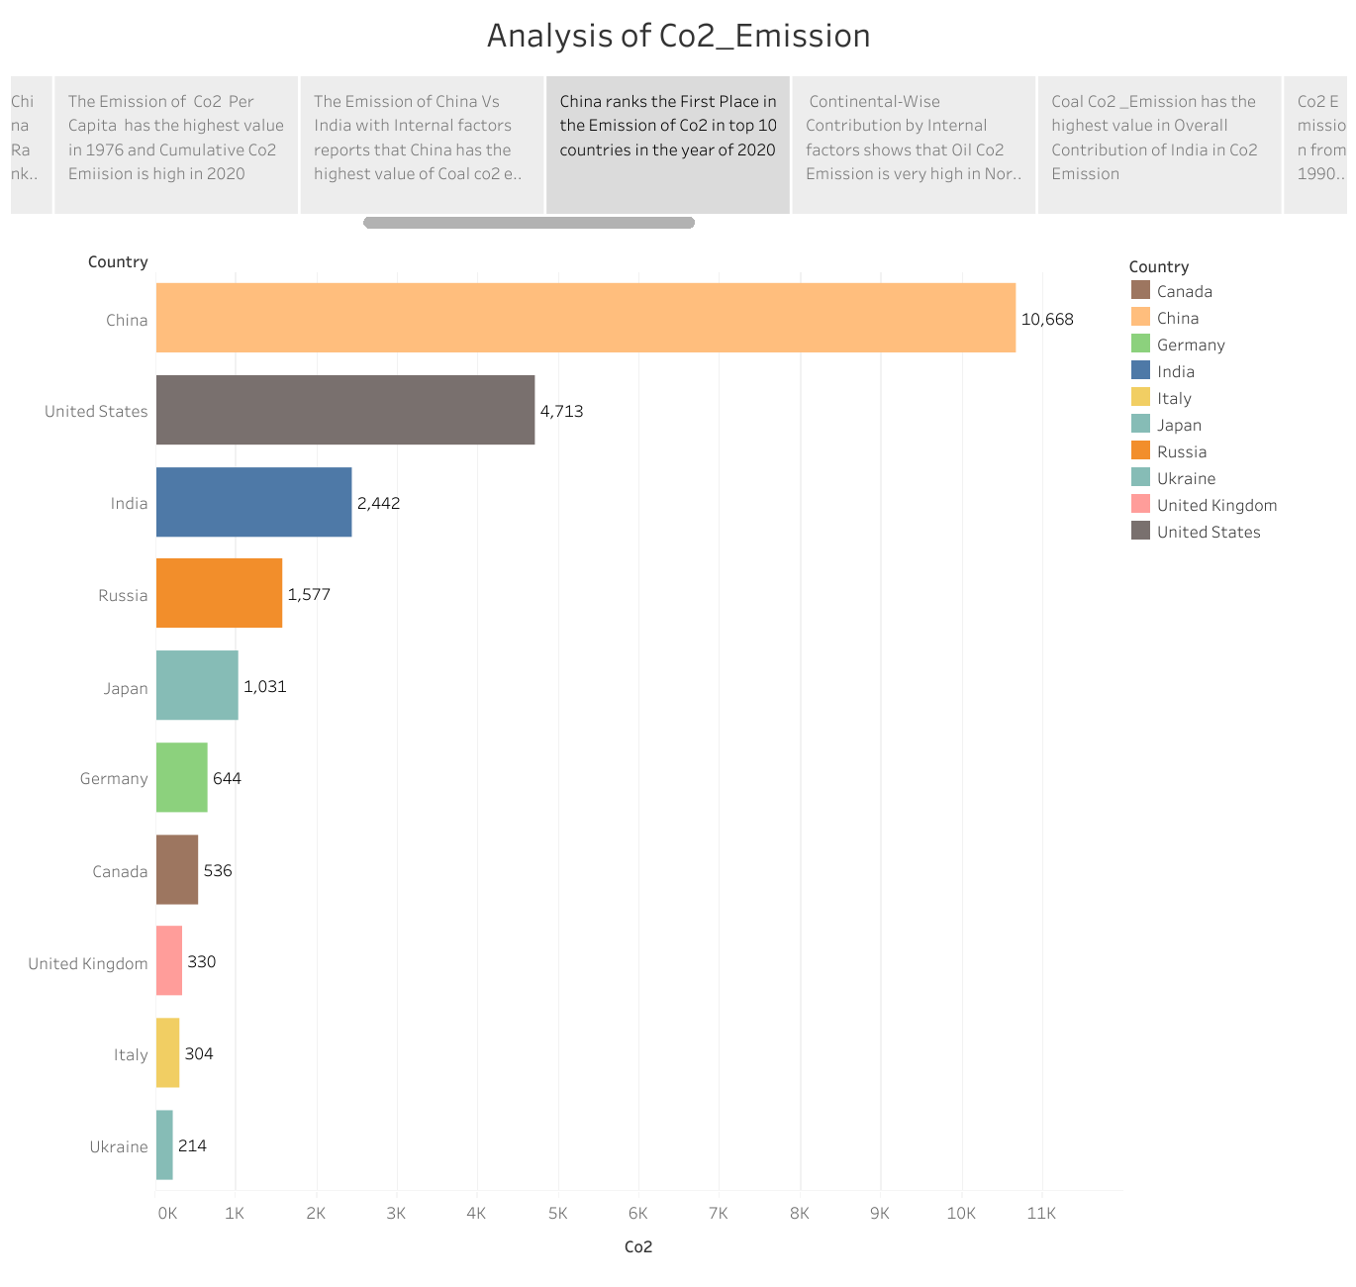

* Continental wise contributes by Internal factors shows that oil CO2 emission is very high in North America.

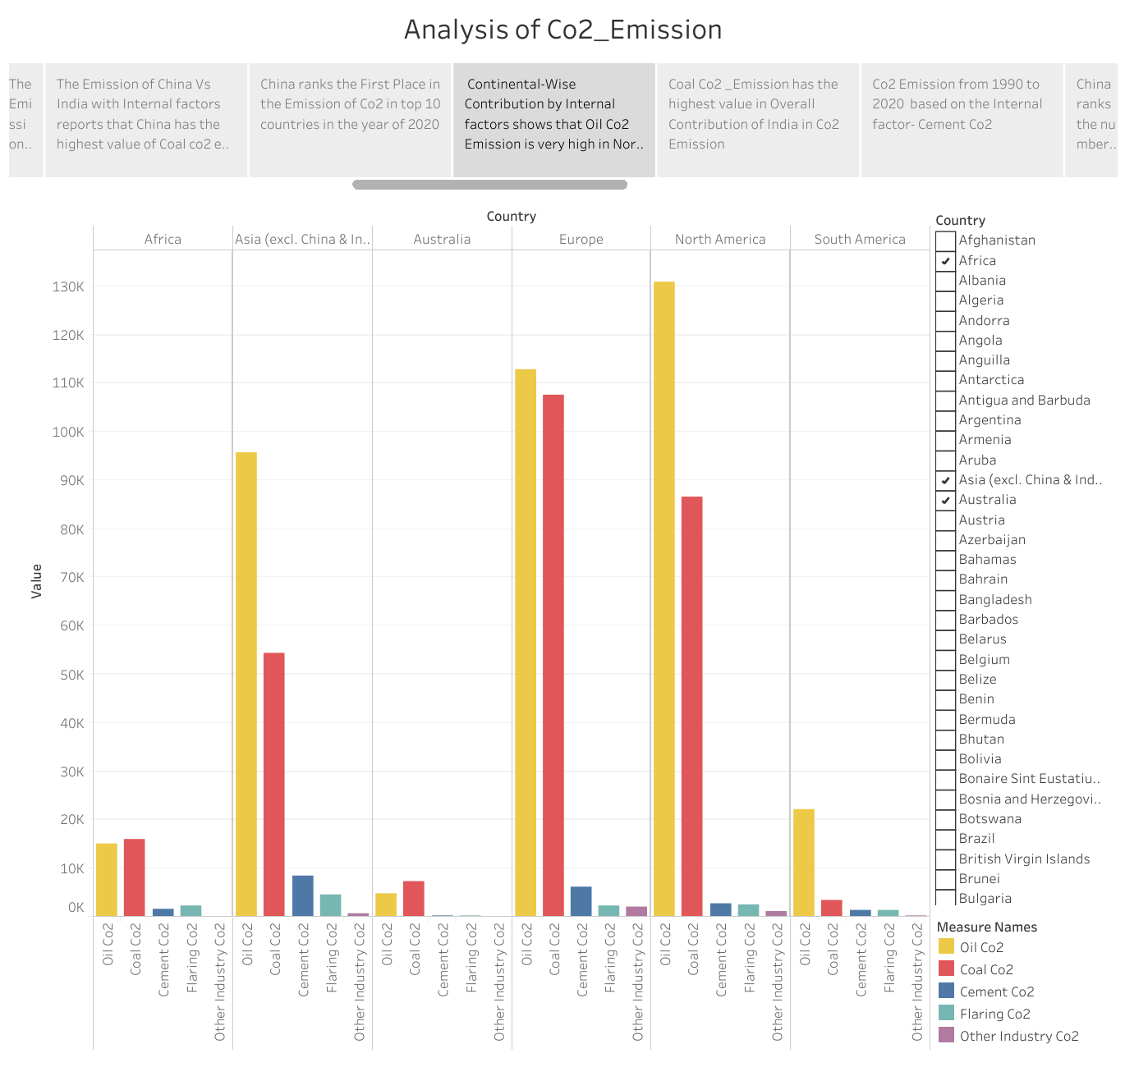

* Coal CO2 emission has the highest value in overall contribution of India in Co2 emission.

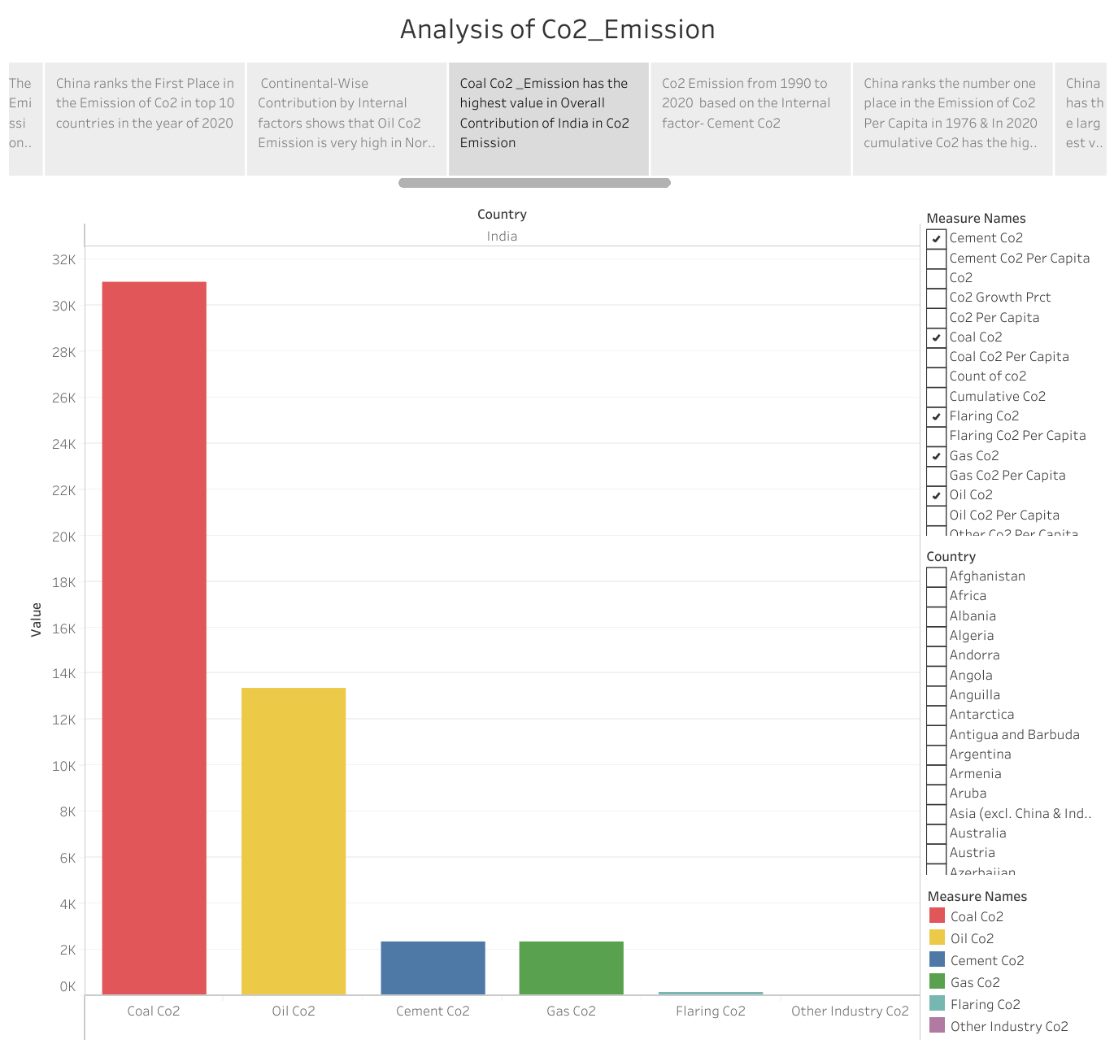

* CO2 emission from 1990 to 2020 based on the Internal factors- cement CO2.

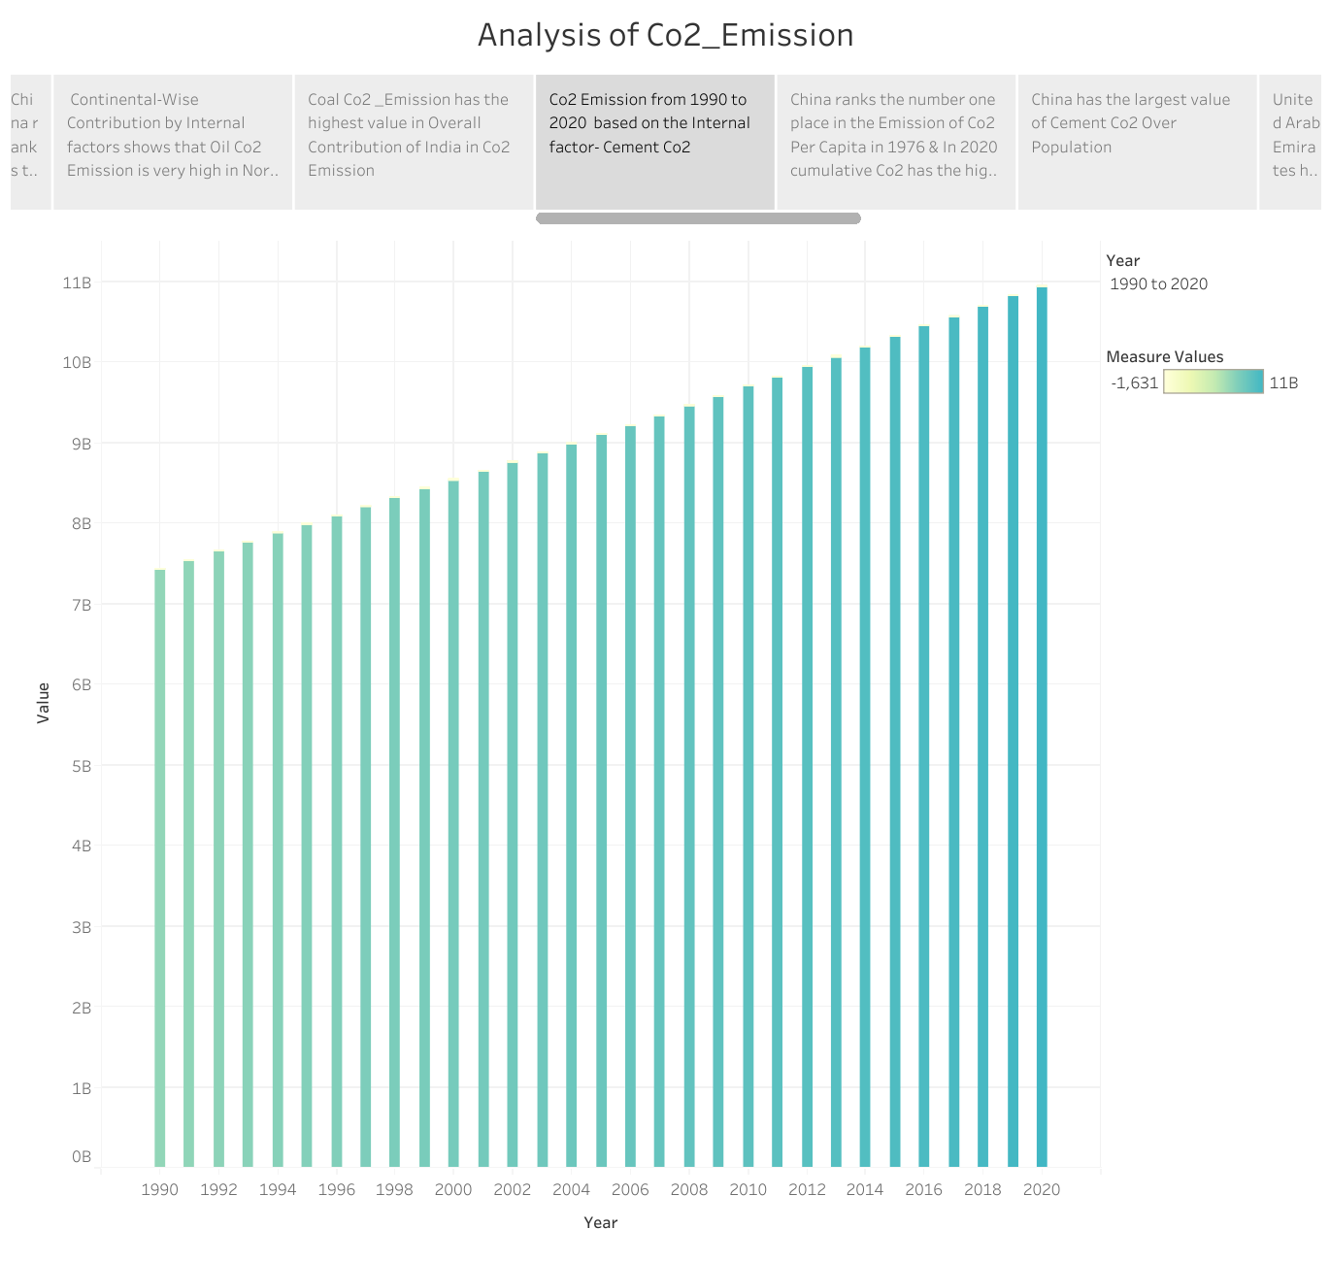

* China ranks the number one place in the emission of CO2 per capita in 1976 and In 2020 cumulative Co2 has the highest value.

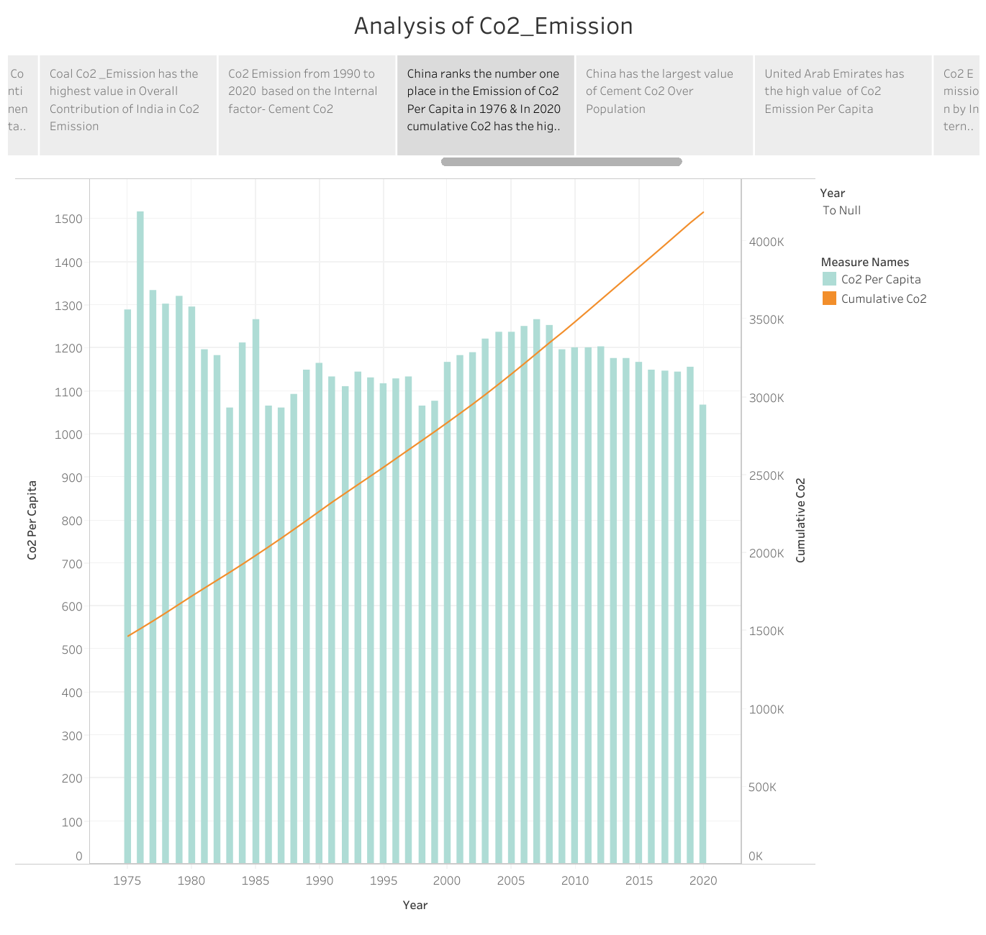

* China has the largest value of cement CO2 Over population.

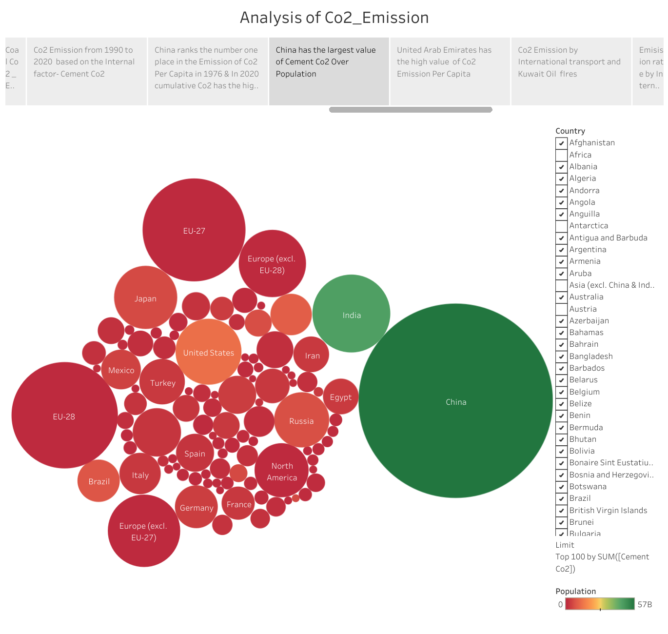

* United Arab emirates has the high value of CO2 emission per capita.

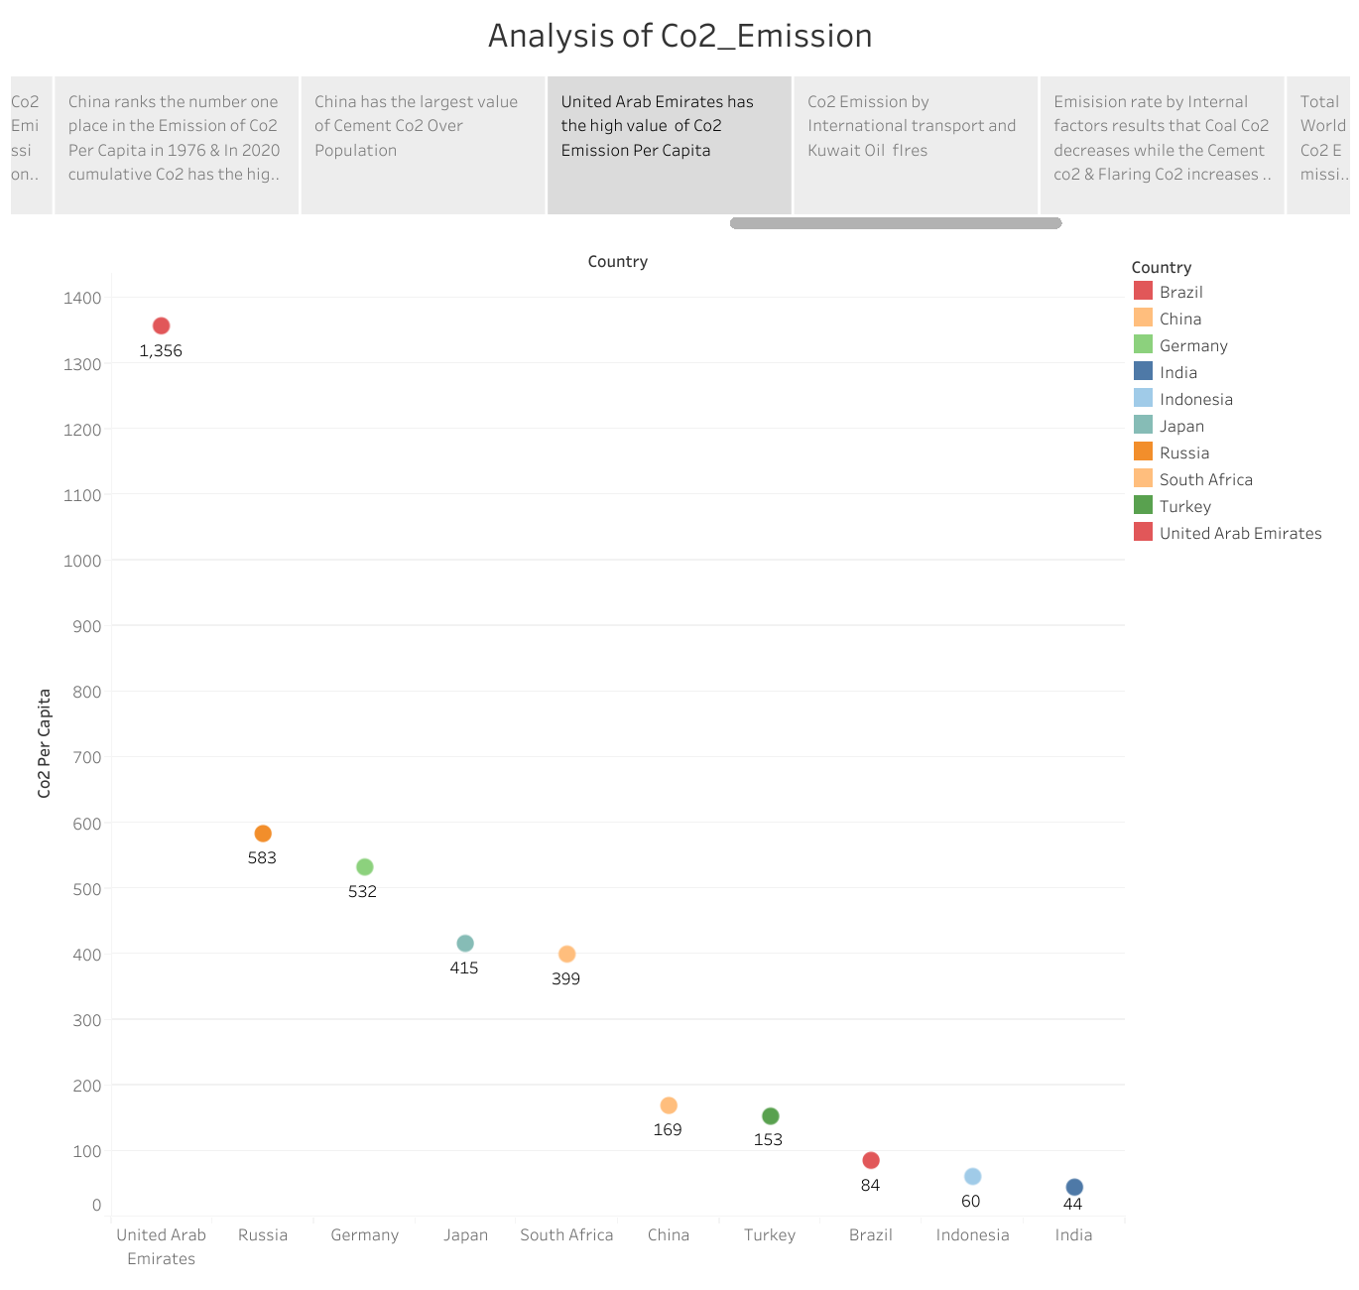

* CO2 emission by the international transport and Kuwait oil fires.

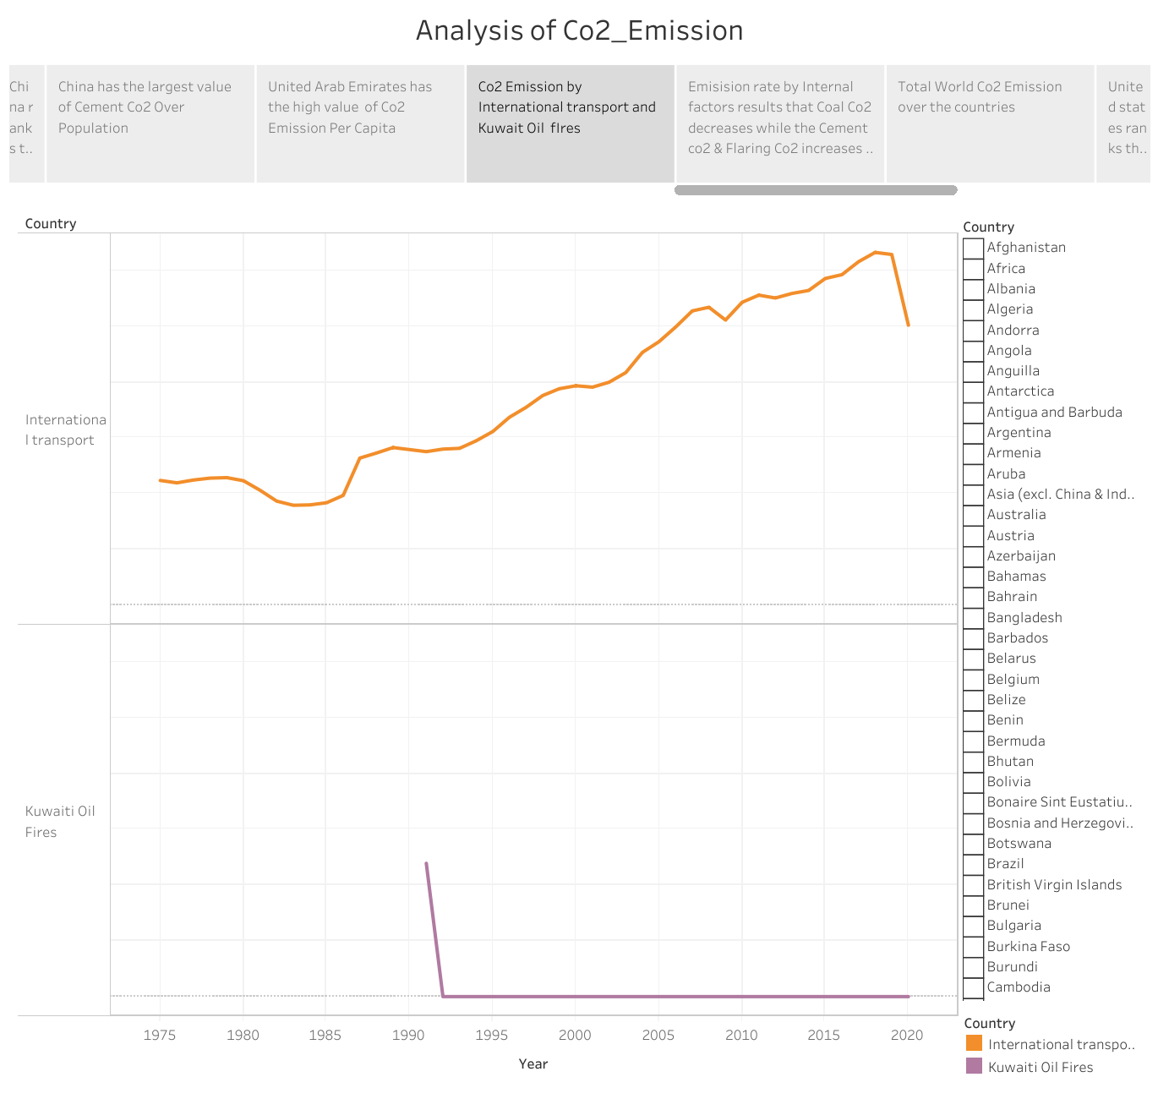

* Emission rate by internal factors results that Coal CO2 decrease while the cement CO2 and flaring CO2 increase in 2020.

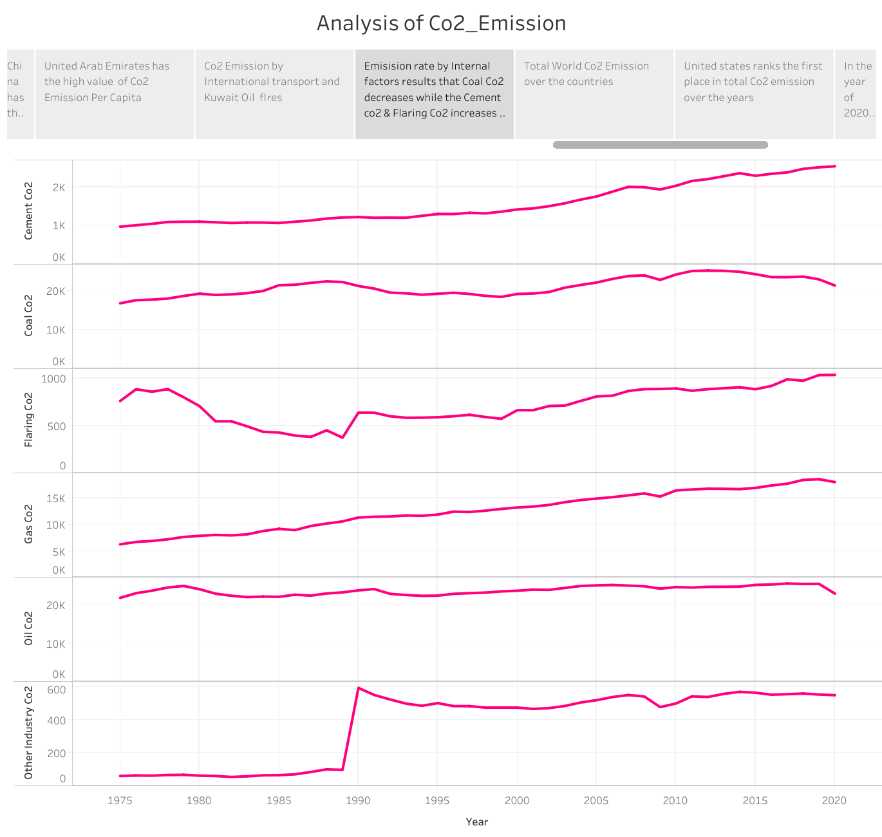

* Total world CO2 emission over the countries.

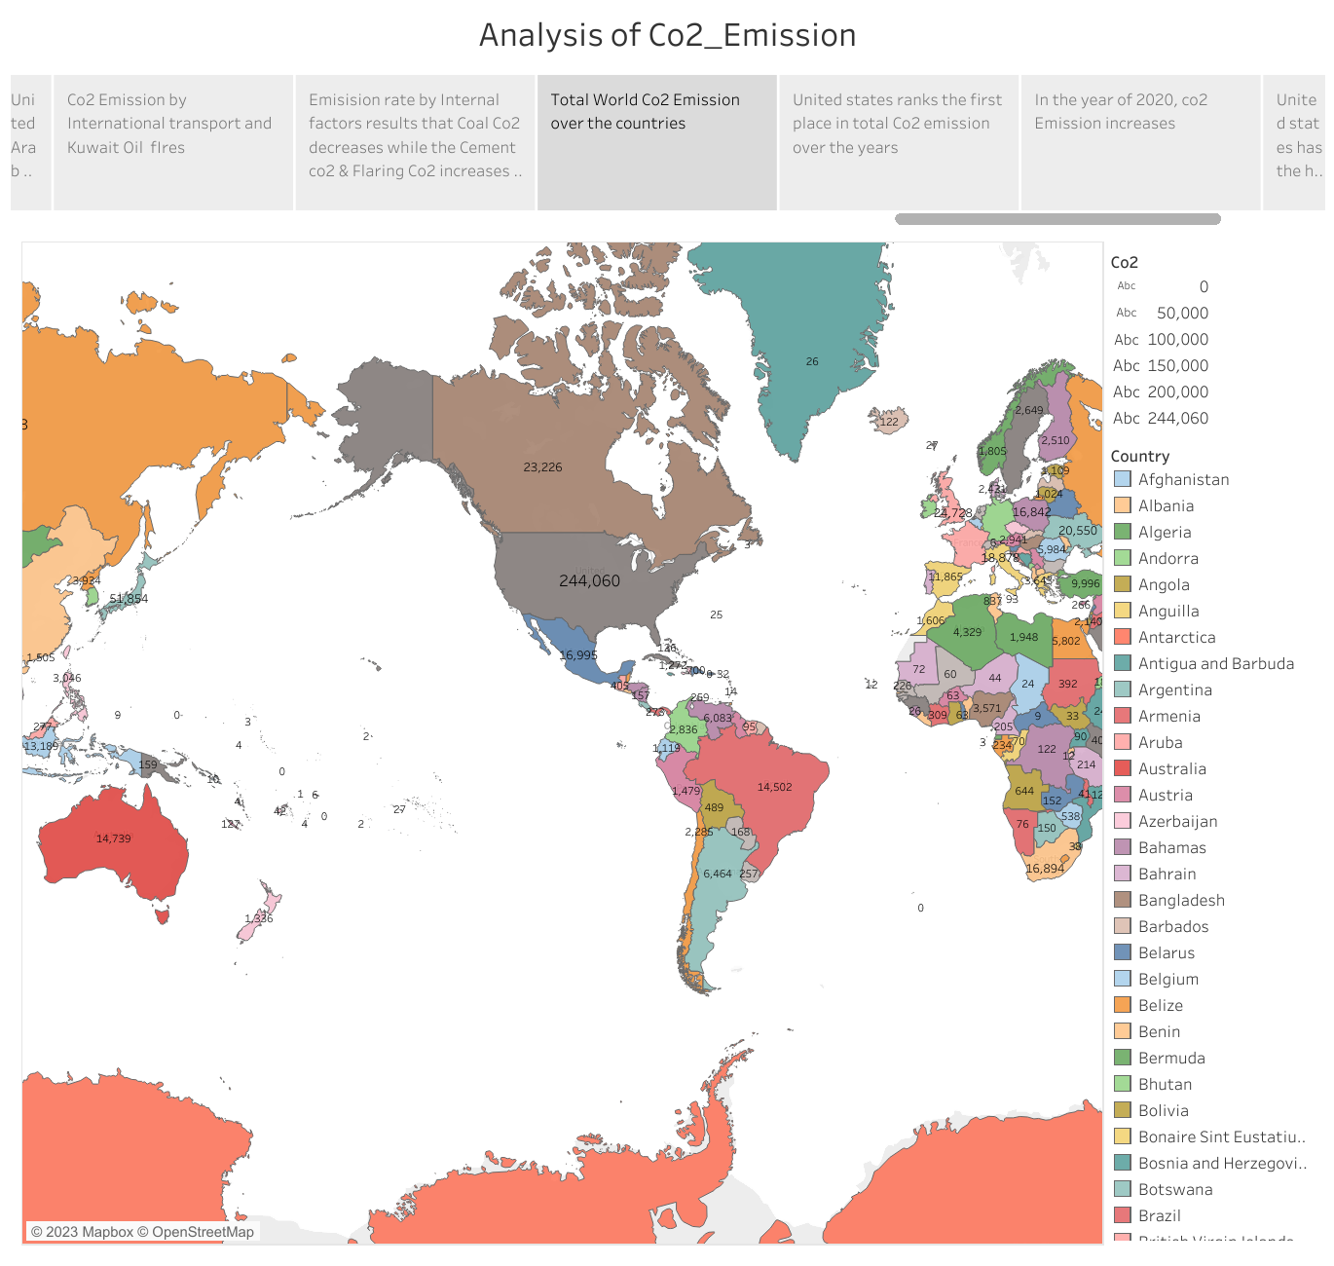

* United States ranks the first place in total CO2 emission over the years.

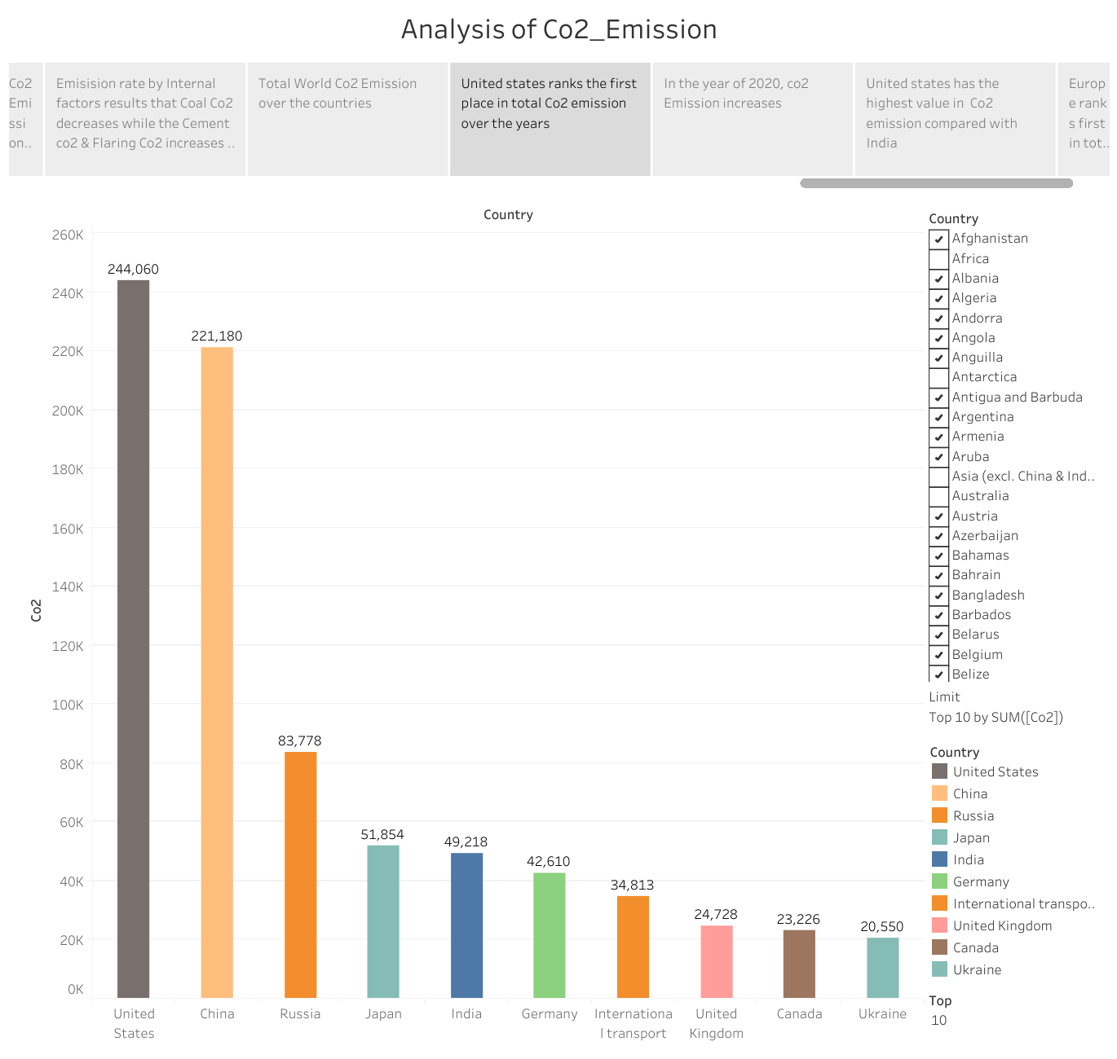

* In the years of 2020, CO2 emission increases.

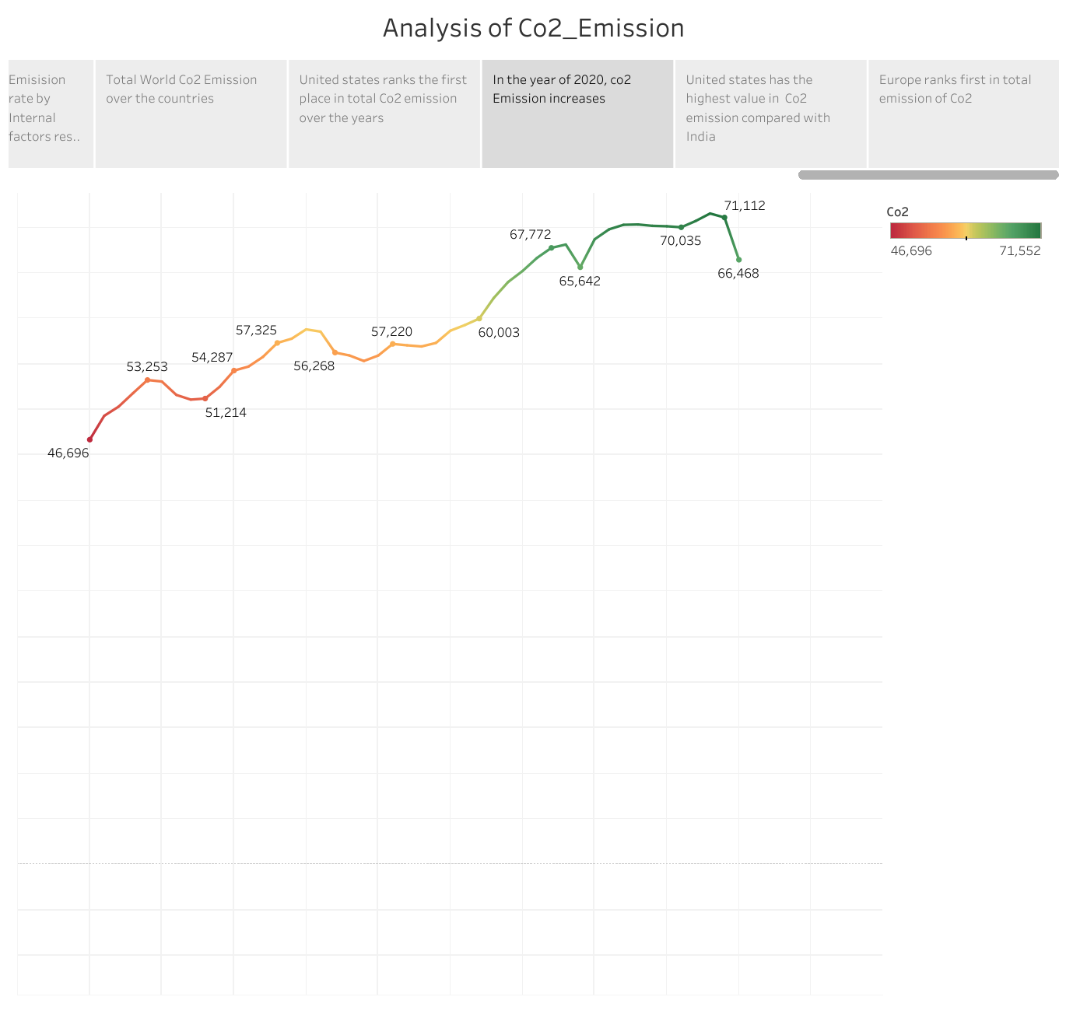

* United States has the highest value in CO2 emission compared with India.

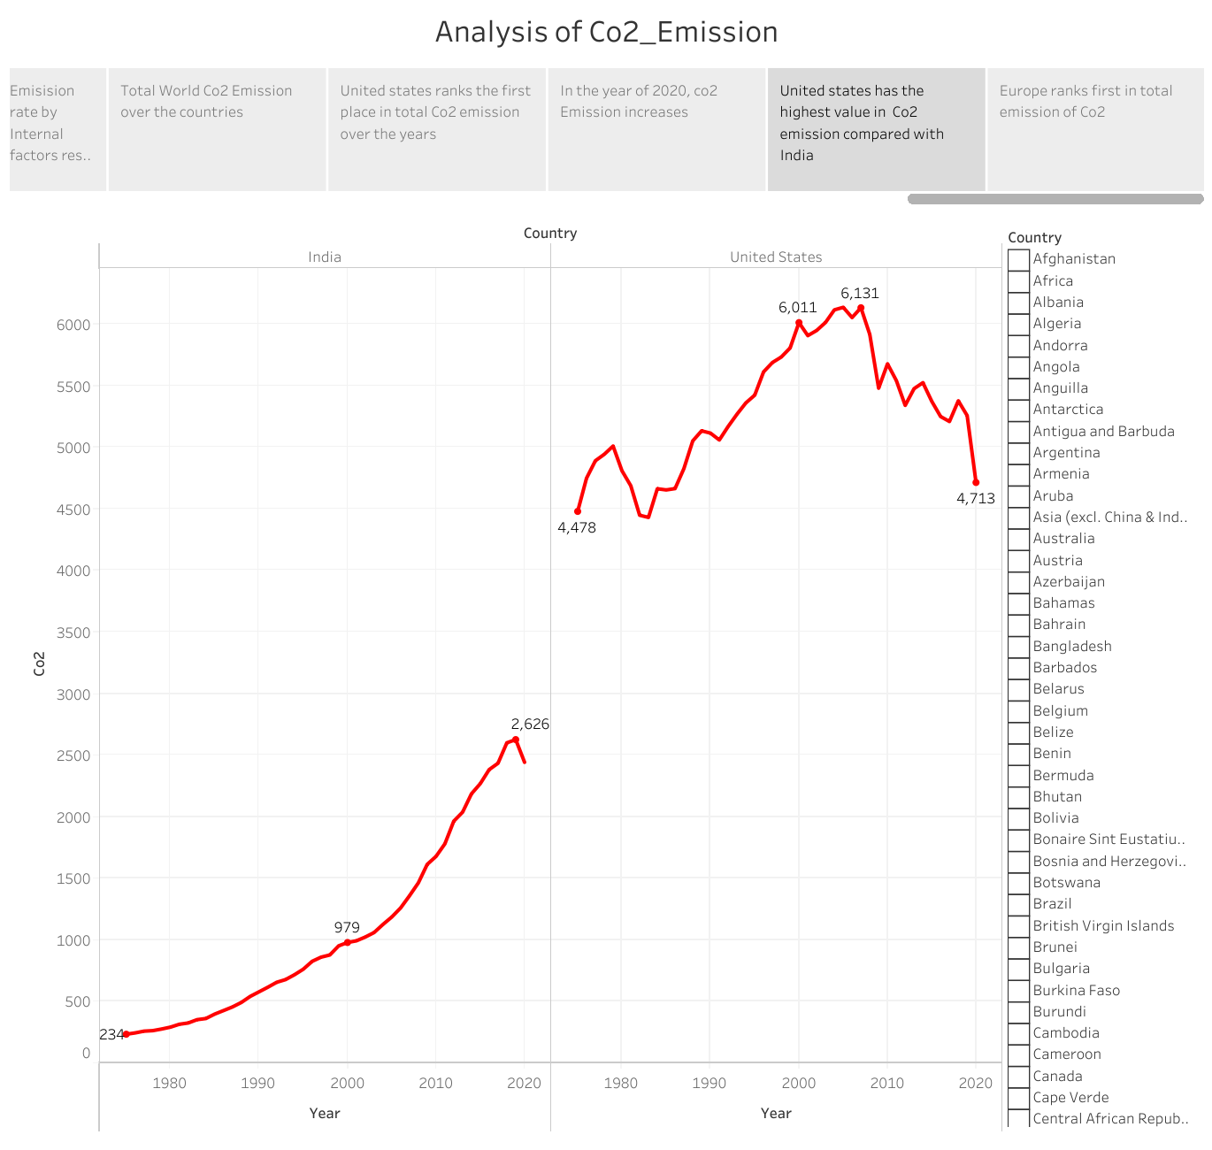

* Europe ranks the first in total emission of CO2.

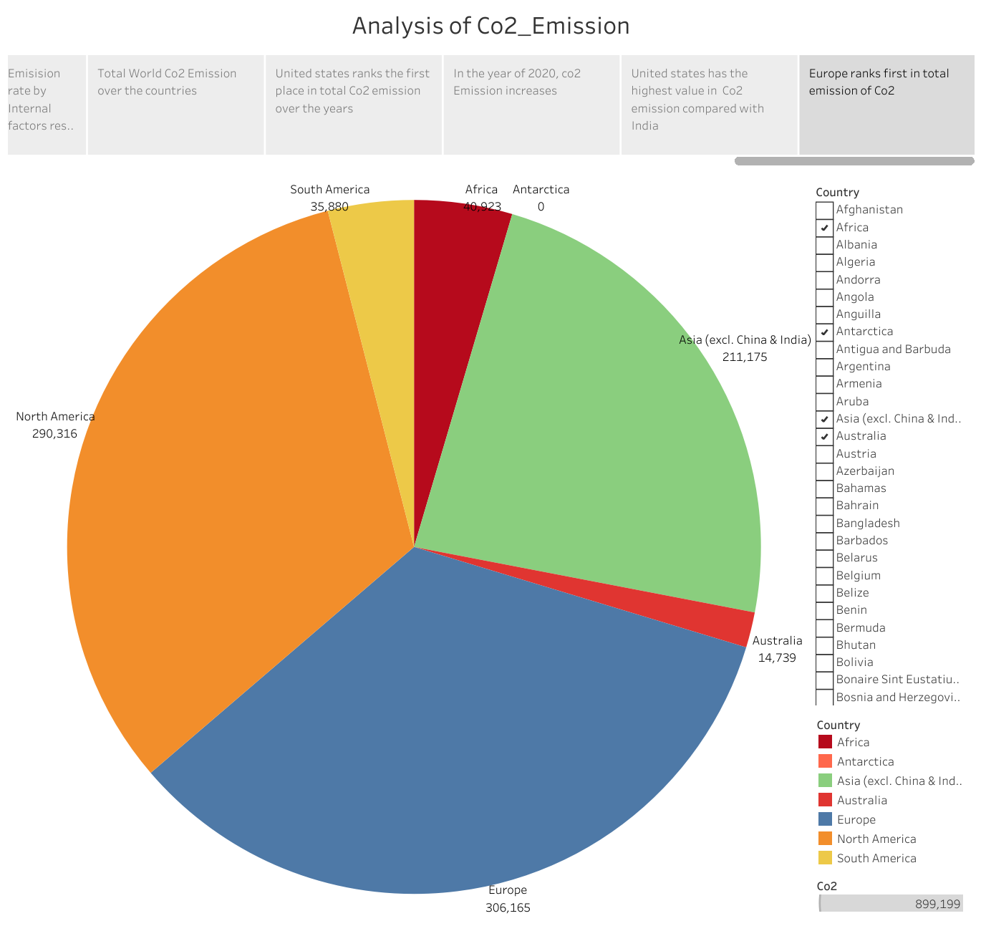

4 **Advantages & Disadvantages** :

Advantages:

* CO2 is an important greenhouse gas that helps to trap heat in our atmosphere.
* Without CO2 our planet would be inhospitably cold.
* An Increase in CO2 concentrations in our atmosphere is causing average global temperature to rise, disrupting other aspects of Earth’s climate.
* Reducing the CO2 emission improves the air quality and benefits human health.

Disadvantages:

* High Co2 levels can cause poor air quality and can even extinguish pilot light on gas powered appliances.
* The changes in concentration causes warming and is affecting various aspects of climate, including surface air and ocean temperature, precipitation and sea levels.
* Human health, agriculture, water resources, Forest resources, forests, wild life and coastal areas are Vulnerable to climate change.
* High Temperature have negative effects an crops and livestock.

1. Applications

Industry:

Many companies are setting emissions Goals and taking steps to reduce emission from industries

Agriculture:

* Heavy chemicals and petroleum based fertilizers are responsible for 50% of the emissions in the sector.

1. Conclusion

* Increased emissions from coal more than offset reductions from natural gases.
* The biggest Sector increase in emissions in 2022 came from electricity and heat generation.
* China’s emissions were relatively flat in 2022 declining by 23 Mt or 0.2%.

1. Future scope

* Emissions from fossil fuels burnt directly. Eg (onsite energy consumption)
* Emissions from bought energy. Eg(electricity purchased)
* Emissions across an organisation’s supply chain – Upstream and downstream emissions beyond your operations.

. 8 Appendix

A. Source Code : <https://public.tableau.com/views/co2_emission_db1/Co2Emission_dashboard?:language=en-US&:display_count=n&:origin=viz_share_link>

<https://public.tableau.com/views/co2_emission_DB2/Co2Emissiondb_2?:language=en-US&:display_count=n&:origin=viz_share_link>

<https://public.tableau.com/views/co2_emission_db3/Co2_Emission_Dashboard3?:language=en-US&:display_count=n&:origin=viz_share_link>

<https://public.tableau.com/views/co2_emission_db4/Co2_Emission_Dashboard4?:language=en-US&:display_count=n&:origin=viz_share_link>

<https://public.tableau.com/views/co2_emission_db5/Co2_Emisision_Dashboard5?:language=en-US&:display_count=n&:origin=viz_share_link>

<https://public.tableau.com/views/co2_emission_story/AnalysisofCo2_Emission?:language=en-US&:display_count=n&:origin=viz_share_link>